MODULE 5 Assignment

Name: N.Rachana
Creating Ancillary Table in Power BI (Detailed Steps) Step 1: Open Power Query Editor
- Open your Power BI file
- Go to Home tab
- Click on “Transform Data”
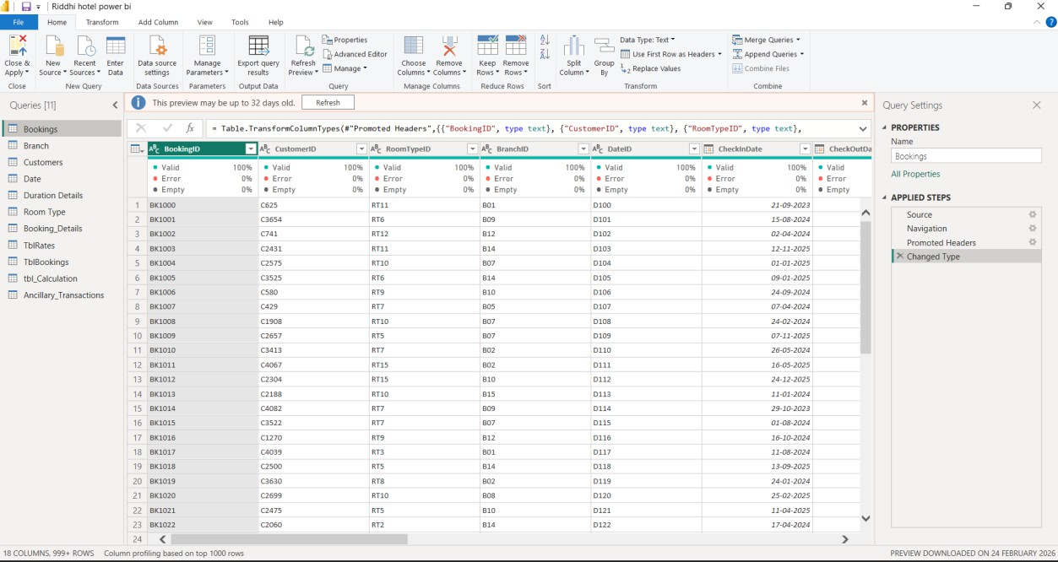
This will open Power Query Editor

Step 2: Create Blank Query
- In Power Query, go to Home tab
- Click New Source → Blank Query
- A new query named Query1 will appear on the left side

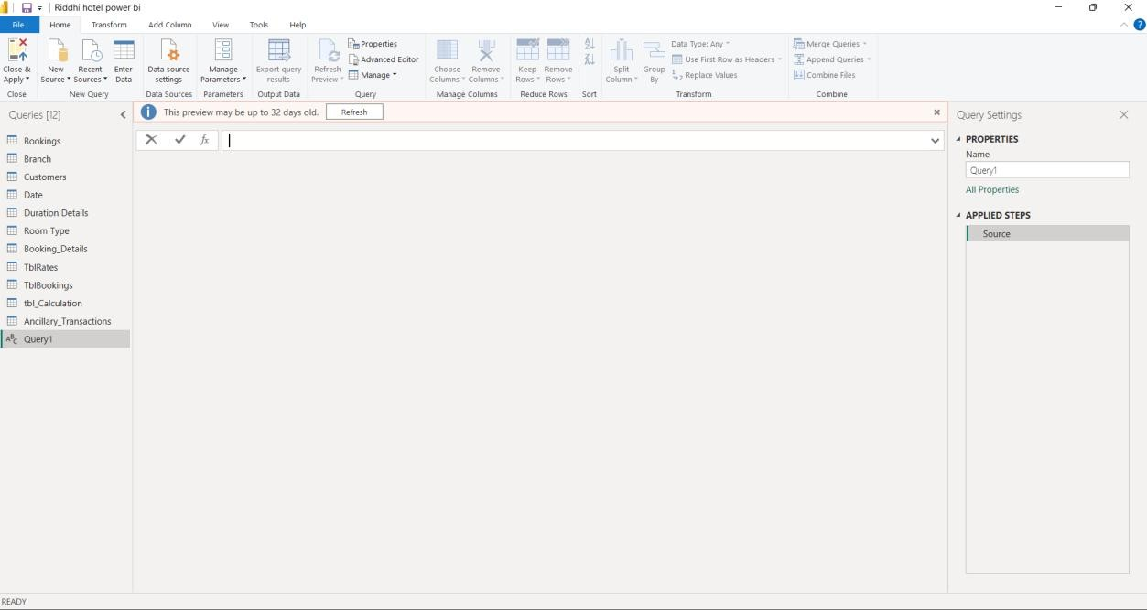
Step 3: Open Advanced Editor
- Select Query1
- Click on Advanced Editor (top ribbon)
- A window will open with some default code
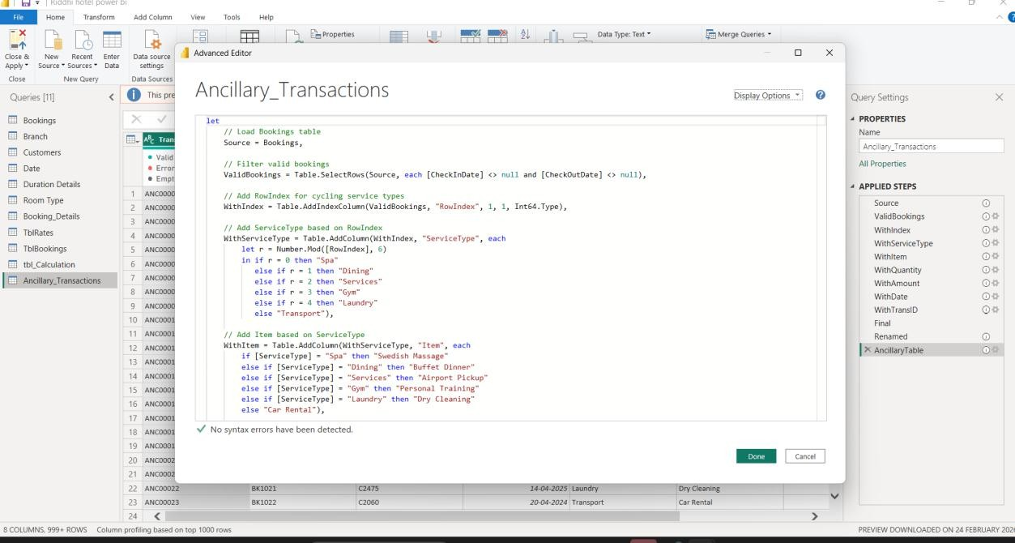
Step 4: Replace with Given Code
- Delete the existing code completely
- Copy and paste your Ancillary table M code
- Click Done
Now Power BI will process the steps and generate the table


- Step 5: Load the Table
  - Click Close s Apply (top left)
  - Power BI will return to main screen
Your Ancillary Transactions table is created successfully
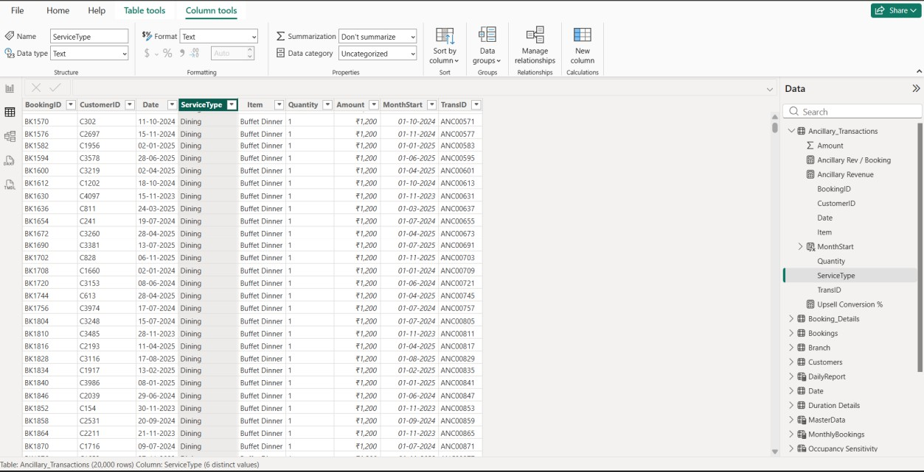

Steps to Add Measures in Ancillary_Transactions Table
- Go to Report View or Data View
- In the Fields pane, select Ancillary_Transactions table
- Click on New Measure (top ribbon)

- Paste one formula and press Enter
- Repeat the same for each measure

Measures to Create
- Ancillary Revenue
Ancillary Revenue = SUM(Ancillary_Transactions[Amount])

- Ancillary Rev / Booking
Ancillary Rev / Booking = DIVIDE(
SUM(Ancillary_Transactions[Amount]), COUNT(Bookings[BookingID])
)

- Upsell Conversion %
Upsell Conversion % = DIVIDE(
DISTINCTCOUNT(Ancillary_Transactions[BookingID]), DISTINCTCOUNT(Bookings[BookingID])
)
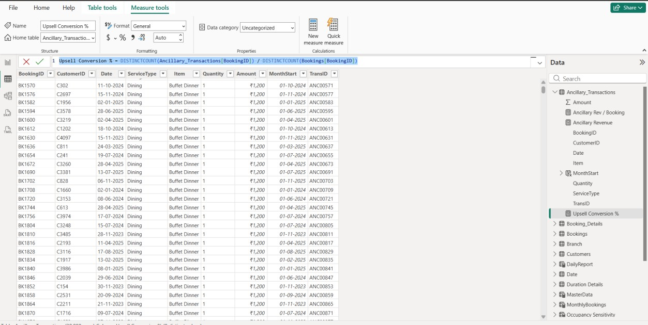

Steps to Create What-If Parameters in Power BI Step 1: Create “Price Uplift %” Parameter
- Go to the Modeling tab
- Click New Parameter → What-If Parameter
- Configure the following:
  - Name: Price Uplift %
  - Data Type: Decimal Number
  - Minimum: -0.10
  - Maximum: 0.20
  - Increment: 0.01
  - Default: 0
- Click OK
Output Created Automatically:
- Table: Price Uplift %
- Measure: Price Uplift % Value
- Slicer added to report
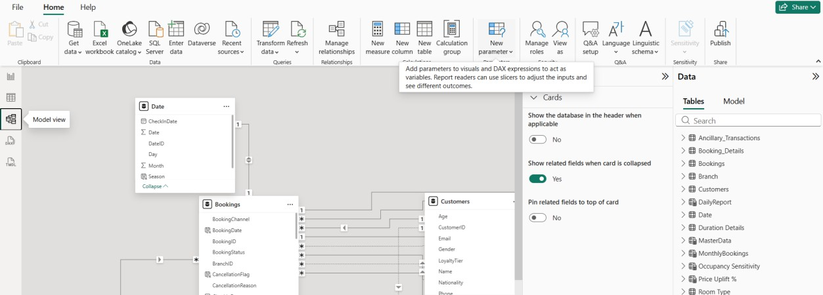

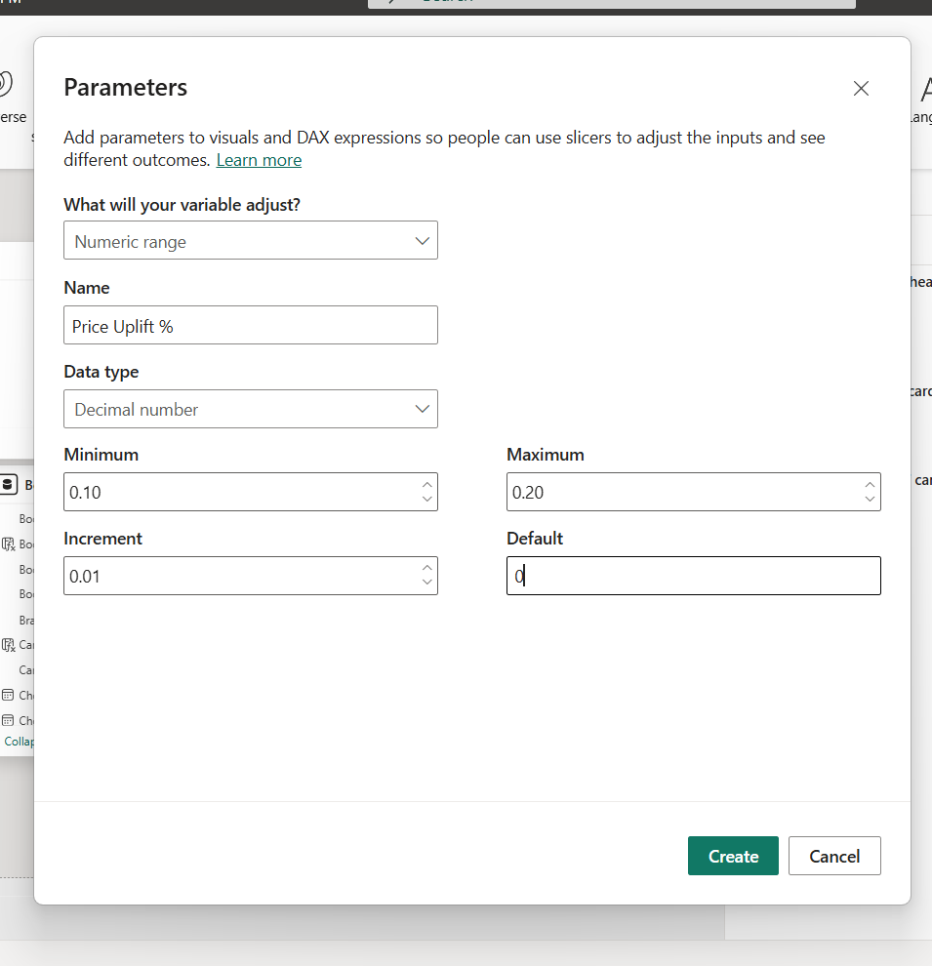
Step 2: Create “Occupancy Sensitivity” Parameter
- Go to the Modeling tab
- Click New Parameter → What-If Parameter
- Configure the following:
  - Name: Occupancy Sensitivity
  - Data Type: Decimal Number
  - Minimum: 0.8
  - Maximum: 1.2
  - Increment: 0.05
  - Default: 1

- Click OK
Output Created Automatically:
- Table: Occupancy Sensitivity
- Measure: Occupancy Sensitivity Value
- Slicer added to report


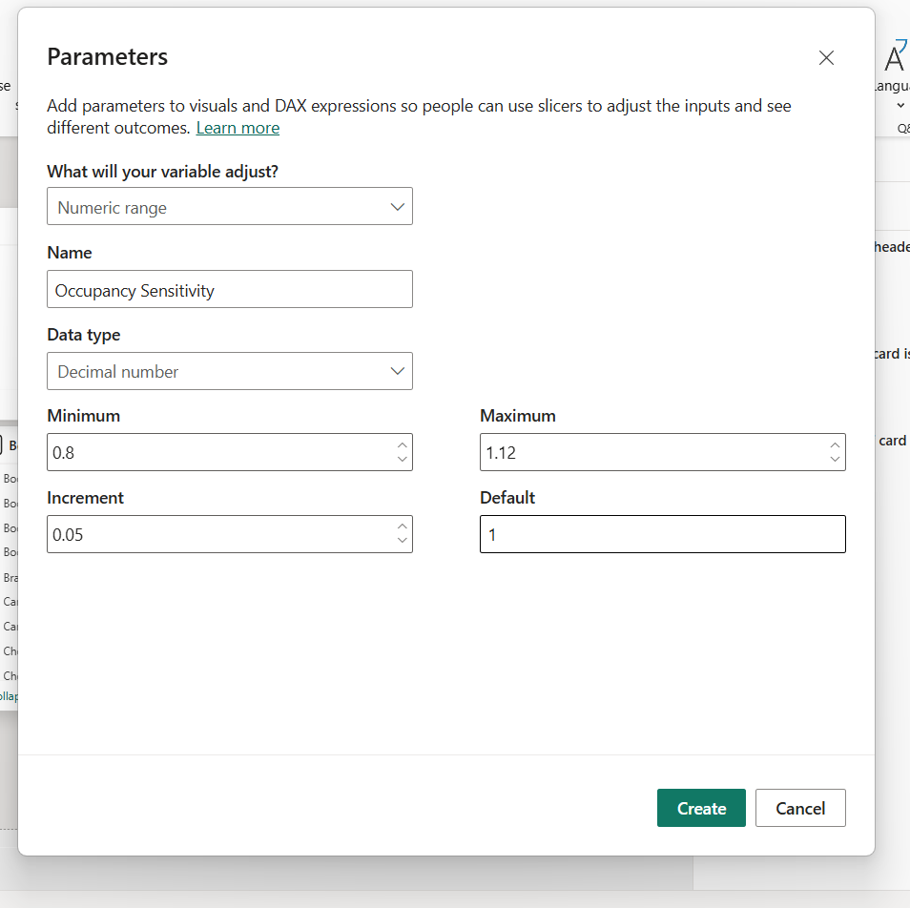

Creating Visuals
- 100% Stacked Column Chart
(X-axis: MonthStart, Y-axis: Sum of Amount, Legend: ServiceType) Steps:
  - Select 100% Stacked Column Chart
  - Drag fields:
    - X-axis → MonthStart
    - Values → Amount (set aggregation = Sum)
    - Legend → ServiceType

Important Settings:
- Click dropdown on MonthStart → select MonthStart (not hierarchy)
- Go to Format → X-axis → Type = Categorical
- Turn ON Data labels (optional)
- Title: Sum of Amount by Month and Service Type
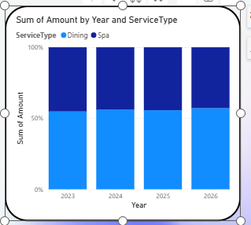
- Pie Chart
(Legend: ServiceType, Values: Sum of Amount) Steps:
  - Select Pie Chart
  - Drag:
    - Legend → ServiceType
    - Values → Amount (Sum)

Formatting:
- Go to Format → Detail labels
  - Show Value + Percentage
- Title: Sum of Amount by Service Type

- Apply your blue gradient colors
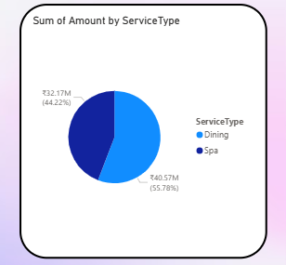
- Matrix Table
(Rows: ServiceType, Columns: MonthStart, Values: Sum of Amount, Count of TransID) Steps:
  - Select Matrix visual
  - Drag:
    - Rows → ServiceType
    - Columns → MonthStart
    - Values →
      - Amount (Sum)
      - TransID (Count)

Important Settings:
For Month Order:
- Ensure MonthStart is sorted properly
- Use Sort by MonthNumber if needed

Formatting:

- Turn ON:
  - Subtotals
  - Grand totals
- Adjust:
  - Column width
  - Text size
- Title: Service Type Performance by Month

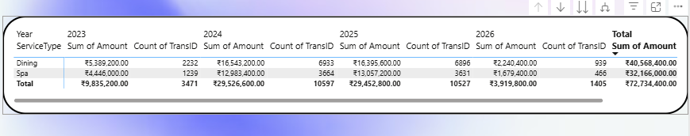
Final Dashboard
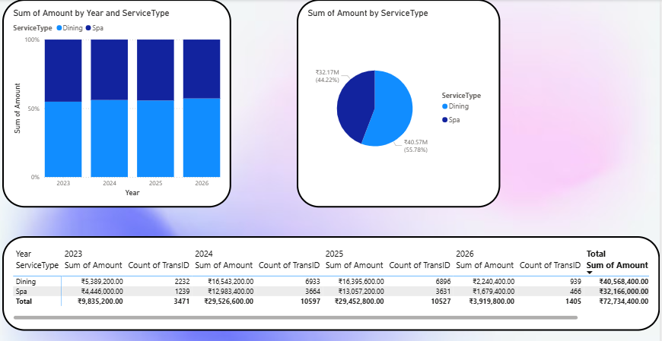
Another Dashboard

- Matrix Table
(Rows: RoomType, Columns: Season, Values: Recommended Price)
Steps:
  - Select Matrix visual
  - Drag fields:
    - Rows → RoomType
    - Columns → Season (from Date/Season table)
    - Values → Recommended Price (measure)
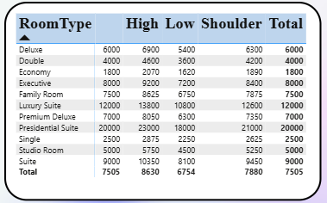

- Slicers for Parameters Slicer 1: Price Uplift % Steps:
  - Select Slicer visual
  - Drag:
    - Price Uplift % (column)
  - Change slicer type:
    - Dropdown → Between (Slider)
  - Title: Price Uplift %

Slicer 2: Occupancy Sensitivity Steps:
- Select Slicer visual
- Drag:
  - Occupancy Sensitivity (column)
- Change slicer type:
  - Between (Slider)
- Title: Occupancy Sensitivity

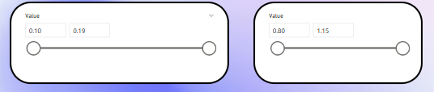

Final Dashboard
